Sierra Youth Football League 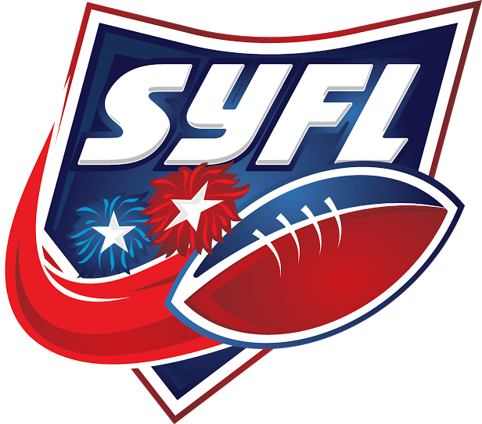
Of Northern Nevada, Inc.
www.gosyfl.com
1275 Kleppe Lane #1 Sparks, Nevada 89441
Tax ID: 88-0451518

20__ Football/Cheer Season
Dear Youth Athletic Enthusiast,

The Sierra Youth Football League is a non-profit organization dedicated to serving the youth of Nevada. The SYFL was founded in 2000 and has grown steadily each year. Funds generated in Nevada through voluntary tax-deductible contributions are used to:

- Sponsor teams or individual scholarships
- Purchase equipment
- Pay for practice fields, game fields, officials and insurance
- Educate children and young adults in the fundamentals of football, cheerleading and sportsmanship

The SYFL’s ambition is to teach teamwork, athletic and life skills to boys and girls between the ages of 5 and 14 in a safe and organized program. We need the help and support of local business and community to assist in meeting the needs a youth program demands. Please help the SYFL to continue to grow and provide excellent opportunities for our children.

Team/League Donation
TEAM NAME: DONATION AMOUNT: $
DIVISION: ❑Bandits ❑Mavericks ❑Freshman ❑Junior Varsity ❑Varsity ❑Collegiate
❑Football ❑Cheer

Please return this form with your check payable to: Sierra Youth Football League, 1275 Kleppe Lane #1 Sparks, Nevada 89441
Sponsor Name: Phone:
Company:
Address:
City: | State: | Zip:
Donation Amount: $
CC: EXP Date: CVC:
We also accept Visa and Mastercard

Thank you on behalf of everyone at the Sierra Youth Football League!

-Board of Directors

